|  |  |
| --- | --- |
|  | http://carbon.ucdenver.edu/~ydeng/fig/CU-Engineering.png |

**Data Architecture Enabling Robust Cooperative Autonomy**

**with Minimal Information Exchange**

Option Phase Progress Report No. 2

STTR Phase 1, Contract N68335-17-C-0349

June 4, 2018

Contract No: N68335-17-C-0349

Prime Contractor Name: Orbit Logic Incorporated

Prime Contractor Address: 7500 Greenway Center Drive, STE 1070

Greenbelt, MD 20770

http://www.orbitlogic.com

(301) 982-6232

Subcontractor: University of Colorado, Dept. of Aerospace Engineering

Subcontractor Address: ECOT-634, 429 UCB

Boulder, CO 80309-0429

http://www.colorado.edu/aerospace

(303) 735-4900

Distribution authorized to U.S. Government Agencies only, Proprietary Information, DFARS STTR Data Rights, 30JUL2017. Other requests for this document shall be referred to the ONR Program Manager.

WARNING: This document contains technical data whose export is restricted by the Arms Export Control Act (Title 22, U.S.C., Sec. 2751, et seq.) or the Export Administration Act of 1979, as amended, Title 50 U.S.C. app. 2401 et seq. Violations of these export laws are subject to severe criminal penalties. Disseminate I.A.W. the provisions of the DOD Directive 5230.25.

This contract (but not this document) includes restricted data rights I.A.W. DFARS 252.227-7018(f).

UNCLASSIFIED

|  |  |
| --- | --- |
| **Project Title** | Data Architecture Enabling Robust Cooperative Autonomy  with Minimal Information Exchange |
| **Topic Number** | N17A-T029 |
| **Contract Number** | N68335-17-C-0349 |
| **Period Covered** | 04/04/2018 - 06/04/2018 |
| **Principal Investigator** | Kenneth Center, PhD |
| **Security Classification** | Unclassified |
| **Item Number** | 0004 |

**Summary**

TODO.

# Milestone/Task Status

The status, percentage of completion, and an updated schedule for each task are given in Table 1. Note that only Phase I Base tasks are included (not the option phase tasks included in the proposal).

**Table-1 Summary of Updated Schedule, Completion Percentage, and Task Status**

|  |  |  |  |
| --- | --- | --- | --- |
| **Milestone** | **Status** | **Completion %** | **Completion Date** |
| Task O1 – Program Management | On Schedule | 25% | 10/09/18 |
| Task O2 – Fleet Planning Tool | On Schedule | 25% | 8/16/18 |
| Task O3 – Ferrying Algorithm Development | On Schedule | 15% | 9/16/18 |
| Task O4 – Architecture Refinement | On Schedule | 30% | 9/10/18 |
| Option Progress Report 1 | Complete | 100% | 6/4/18 |
| Option Progress Report 2 | Not Started | 0% | 8/6/18 |
| Final Report | Not Started | 0% | 10/9/18 |

The Option Phase project schedule is included in Figure 1 below for reference. The green horizontal line indicates the current reporting date. As can be seen, we are technically on target.



**Figure 1. Option Phase technical schedule as Gantt chart**

Progress associated with each of the technical tasks from the contractor statement of work is discussed (where relevant) in the subsections to follow.

**Task B1 – Program Management**

TODO.

**Task O2 –Baseline Tool to Generate Fleet Plans and Behaviors**

TODO

**Task O3 – Ferrying Solution Algorithms for Resource Conservation**

1. **Models**

The ferrying algorithms require a model of the air vehicle and the Wi-Fi communication between the air vehicle and the AUVs. The air vehicle is assumed to be a quadcopter with a maximum ground speed, $V_{g}$. For simplicity of implementation, it is assumed that the quad can simply travel at this speed in any arbitrary direction. Although this may seem unrealistic, the maximum speed could be lowered in the problem initialization to account for the time required to change directions at rendezvous locations.

The communication model is simple free space degradation model. The data rate as a function of distance and source power is given below:

$$rate=\frac{P_{0}}{d^{α}}$$

where $P_{0}$ is the signal strength of the source, $d$ is the distance between the source and the receiver, and $α$ is the signal loss parameter. $α$ typically ranges from 2 (free space theory) to 3.

1. **AUV Surface Rendezvous Optimization**

The surface rendezvous problem begins with a series of grid cells and initial time intervals for the AUVs to surface within. The goal of the optimization algorithm is to find the 2D surface locations and narrower surface intervals that minimize the total distance between surface locations and allow for a feasible ferrying path. An example problem initialization can be seen in Figure 2.

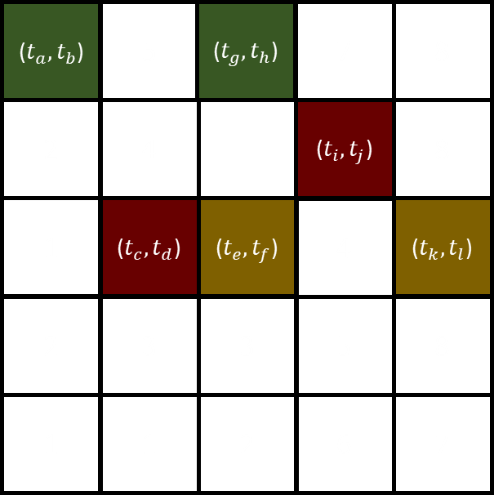

**Figure 2. AUV Rendezvous grid locations and initial intervals**

The surface locations, ($x_{i}{,y}_{i}$), and ferry departure times, $t_{d}$, are determined by solving the convex optimization problem formulated below:

$$\min_{x, y,t_{d}}{\sum_{i=1}^{N-1}{\sqrt{(x_{i+1}-x_{i})^{2}+(y_{i+1}-y_{i})^{2}}}}$$

subject to:

${x_{min,i}≤x}_{i}≤x_{max,i}$ for $i=1…N$

${y_{min,i}≤y}_{i}≤y_{max,i}$ for $i=1…N$

${t_{min,i}+t_{h,i}≤t}_{d,i}≤t_{max,i}$ for $i=1…N$

${\left(\sqrt{(x_{i+1}-x_{i})^{2}+(y_{i+1}-y_{i})^{2}}\right)}/{V_{g}}≤t_{d,i+1}-t_{d,i}+t_{h,i+1}$ for $i=1…N-1$

where $x_{min}$, $x_{max}$, $y_{min}$, $y_{max}$, $t_{min}$, and $t_{max}$ are the grid cell limits for each of the AUV surface locations and time intervals. The first three constraints are self-explanatory, but the last constraint is less obvious. The last constraint makes sure that if the ferry were flying at $V_{g}$, it would have enough time to travel between the surface locations $i$ and $i+1$ and stay at surface location $i+1$ for the harvest time. Satisfying this constraint allows the aircraft enough time to travel between all of the surface locations and also provides some insight into why a problem may be infeasible because of tight timing windows.

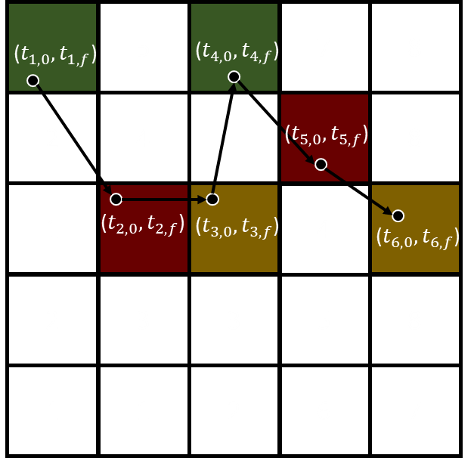

**Figure 3. AUV Rendezvous locations and refined intervals**

The optimization assumes an order for the AUV rendezvous, but an outer loop can be made to determine which visit order minimizes the total distance between surface locations. Since the problem is convex, the minimizing solution always generates surface locations on the edge of the grids.

In the case where the problem is infeasible, a measure of the infeasibility is generated. This measure is the amount of time that each time interval needs to be extended in order for the problem to become feasible. The infeasibility time vector is given as the output if the problem is infeasible in order to generate a more flexible fleet plan.

1. **Ferry Path Optimization**

The ferry path optimization algorithm seeks to find a feasible and fast path for an air vehicle to collect all the available information from the AUVs. The simplest possible path would be to use the AUV surface locations as waypoints for the air vehicle path. We generate a shorter path and formulate a convex optimization problem to determine a path:

$$\min_{x, y}{\sum_{i=1}^{N-1}{\sqrt{(x_{i+1}-x_{i})^{2}+(y_{i+1}-y_{i})^{2}}}}$$

subject to:

$\sqrt{(x_{2j-1}-x_{sub,j})^{2}+(y_{2j-1}-y_{sub,j})^{2}}≤r_{j}$ for $j=1…M$

$\sqrt{(x_{2j}-x_{sub,j})^{2}+(y_{2j}-y_{sub,j})^{2}}≤r_{j}$ for $j=1…M$

Where $x_{sub,j}$ and $y_{sub,j}$ are the AUV surface locations from the previous optimization, $M$ is the number of AUV surface intervals, and $r_{j}$ is the communication radius needed for the ferry to receive all of the data from the $j^{th}$ AUV. $r_{j}$ is determined by solving for distance in the Wi-Fi communication model given a radio power, data package size, and fall-off constant. The equation is given below:

$$r_{j}={∆t}_{s,j}{\left(\frac{P_{j}}{b_{j}}\right)}^{1/α}$$

where ${∆t}_{s,j}$ is the surface interval time, $P_{j}$ is the transmit power, and $b_{j}$ is the amount of data to be transferred. If the ferry is constrained to be within this radius of the AUV during its surface interval, it will always receive the entire data package. This approach quickly generates the shortest ferry path within the communication constraints because of the convex problem structure.

1. **Preliminary Simulations**

A preliminary run of both algorithms was run using the parameters in Table ??. The data package sizes for each AUV are not given and instead package sizes and transmit powers were determined to give a transmission radius of reasonable size around each surfacing AUV. Results are plotted in Figures 4 to 6.

**Table-?? Ferry Optimization Simulation Parameters**

|  |  |
| --- | --- |
| **Parameter** | **Value** |
| Grid dimensions | 8 x 10 |
| Grid width/height | 250 meters |
| Max ferry ground speed ($V_{g}$) | 10 m/s |
| Number of rendezvous ($N$) | 8 |
| Harvest time ($t_{h}$) | 30 seconds |
| Flight altitude ($h$) | 100 meters |
| Comm loss parameter ($α$) | 2.5 |

Figure 4 shows the results of the AUV surface rendezvous optimization. The first AUV surface location is given in green and the last in red. In addition to the physical locations of the rendezvous, the timing windows are given in Figure 5. The red lines represent the initial timing windows for the AUV surfacing intervals, the pink lines represent the refined windows and the blue are the time it takes the ferry to travel from one surface location to the next. This plot shows that the rendezvous algorithm satisfies the scheduling constraint.

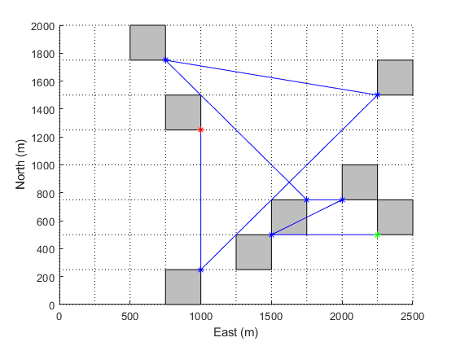

**Figure 4. Preliminary simulation AUV rendezvous locations and refined intervals**

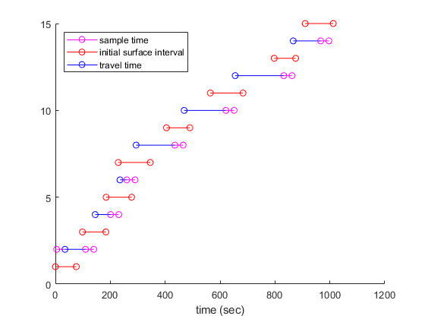

**Figure 5. Preliminary simulation ferry and AUV surface timing**

Figure 6 shows the results from the ferry path optimization. The communication radii are plotted around the AUV surface locations and the ferry path is shown in blue. The optimization does its best to “cut the corner” and shorten the initial path given by the rendezvous optimization.

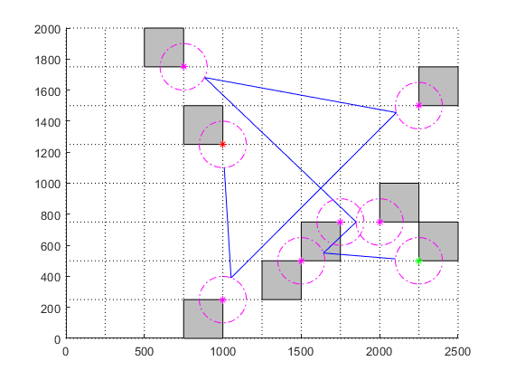

**Figure 6. Preliminary simulation AUV ferry path and communication radii.**

**Task O4 – Architecture Refinement via Enhanced Use Cases**

TODO.

## Issues

TODO.

# Future Plans

**Task O3 – Ferrying Solution Algorithms for Resource Conservation**

1. **Models**

More detailed Quad model

More detailed Communication model

1. **AUV Surface Rendezvous Optimization**

Probably good as is.

1. **Ferry Path Optimization**

Will use the new quad and communication models. The aircraft will need to consider how old its onboard data is, and how full its buffer is to determine whether it’s worth returning home to drop off data before receiving more from the AUVs.

# References

Below are URLs associated with the hardware that SPAWAR is currently using in their HAMMER system development activity. Orbit Logic is utilizing this Master Equipment List (MEL) as the baseline for development of the initial Fleet Planning Solution.

Vapor 55 - <http://www.pulseaero.com/uas-products/vapor-55>

BlueROV2 - <http://docs.bluerobotics.com/brov2/>

ArduSub (autopilot for BlueROV2) - <https://www.ardusub.com/>

USBL acoustic localizing (X150/ X110) - <https://www.blueprintsubsea.com/seatrac/products.php>

WAMV boat - <http://www.wam-v.com/16-wam-v-usv>

# Itemized Costs

Table 2 (below) shows the summary of itemized costs for theSTTR Option Phase**.**

**Table 2. Summary of Itemized Costs for Fixed-Price Contract**

|  |  |  |
| --- | --- | --- |
| **CLIN** | **Funding Amount** | **Amount Invoiced** |
| 0004 | $45,000.00 | $45,000.00 |
| 0005 | $34,500.00 | Not Yet Invoiced |
| 0006 | $20,359.00 | Not Yet Invoiced |
| **Totals** | **$99,859.00** | **$45,000.00** |
| **Remaining Funds** | **-** | **$54,859.00** |

# Contract Delivery Status

The status of all contract deliveries is provided in Table 3.

**Table 3. Summary of Contract Deliveries Status**

|  |  |  |  |
| --- | --- | --- | --- |
| **CLIN** | **Deliverables** | **Date** | **Status** |
| 0004 | Progress Report 1 | 6/4/18 | Delivered |
| 0005 | Progress Report 2 | 8/6/18 | Not Yet Delivered |
| 0006 | Final Report | 10/9/18 | Not Yet Delivered |

# Report Preparer Info

This report was prepared by:

Kenneth B. Center, PhD

Director

Orbit Logic Incorporated

(301) 982-6232, x7006

Ken.Center@OrbitLogic.com